Charles Cameron Tilted Tiles Workshop

  FeltLikeSweets@gmail.com  Instagram: @FeltLikeSweets  Etsy.com/shop/FeltLikeSweets | I'm Charles Cameron, a North Carolina-based Modern Quilter. I share my work on Instagram @FeltLikeSweets.  I’m an Engineer by training and vocation and tend toward creative endeavors to maintain balance.  I have two young daughters who are my creative inspiration. Their playful experimentation and approach toward learning has shown me that not knowing how to do something can be a powerful enabler toward creating something extraordinary: to not be bound by ‘the ways that others do things,’ or ‘the ways that things ought to be done.’  My work explores the use of bright colors and color value placement to enhance more traditional quilt patterns and quilt block design. I’m not afraid to bend what should be a straight line.  My quilts have been published in Curated Quilts, a quarterly journal of and for modern quilters, and have been juried into QuiltCon, the world’s largest modern quilt show, presented by The Modern Quilt Guild. My quilt, Sudoku, was awarded 1st place in the Small Quilts Category at QuiltCon2022. I’ve written and published quilt patterns of my own design, and deliver guild lectures, trunk shows and workshops to share my work and promote modern quilting.

Welcome to the Tilted Tiles Workshop!

Introduction:
‘Semi-improv’ is a technique for those who want the look and feel of improv, but who aren’t quite ready to give up their rulers
The workshop will kick off with a detailed overview of the pattern to orient the participants. Hands-on instruction will be provided for each step of the Tilted Tiles quilt pattern and classroom time will be allowed for participants to progress toward making a 36” x 36” wall handing or 18” x 72” table runner of your own.
The pattern uses efficient, traditional piecing techniques, and multiple block sizes, each with their own choose-your-own-adventure-style instructions for the creation of a one-of-a-kind masterpiece.
Blocks are made from modular subunits which are mixed-and-matched in interesting color and value combinations to create visual interest and flow. The subunits can be assembled in various orientations and sewn together in numerous configurations. The blocks are constructed larger than required using traditional piecing techniques, then trimmed with a ruler, improv-style to give each block a ‘tilted’ or ‘wonky’ look which adds variety and movement to the assembled quit top.

Before the Workshop:
- Please download a .pdf copy of the Tilted Tiles quilt pattern from Etsy:
Link: https://www.etsy.com/listing/1676067713/
- Please read through the Tilted Tiles pattern.
- For the workshop, we will work toward making a 36” x 36” wall handing or 18” x 72” table runner. This will require just 4 Half Yards of fabric. See notes on fabric selection, below.
- Using the cutting instructions, below, please come to the workshop with all fabric cut and labeled. This will allow us to maximize our instruction and sewing time. You will cut the same pieces from each of your 4 (colors) half yards of fabrics.

Workshop Supplies to bring:
- A .pdf copy of the Tilted Tiles quilt pattern

- 4 Half Yards of fabric, cut and labeled following the instructions, below.

- 12½” square quilting ruler. 9½” and 6½” square rulers are also recommended, but not required.

Fabric Selection:
When pulling the 4 fabrics for this workshop, my best advice is: be adventurous! There are no wrong choices!
This pattern was developed with solid fabrics. The pattern’s cover quilt uses Moda solids in Prune, Pomegranate, Raspberry, Tea Rose, Clementine, Peach, and Porcelain, if you’re looking for inspiration.
The best combinations have a variety of color values: 1 light color, 1 dark color and at least 1 mid-tone.
Patterned and directional fabrics can also be used. Just beware that the patterns will not line up when the blocks and quilt are constructed (and that’s o.k.!). This may enhance the overall impact as their colors, shapes and forms interact as a result of the improv construction, trimming and layout options. Consider these as an opportunity for creativity and exploration.
Here are a few other color/pattern/print combinations to consider:
- 3 solids in shades of white/grey/black + 1 bright color or a black and white stripe
- 3 solids of the same hue a light, medium and dark value + 1 contrasting color or print
- 1 colorful pattern and 3 coordinating solids
- 4 colorful, small-scale prints from the same fabric designer or fabric line.
Feel free to share your fabric pull on Instagram; use the hashtag: #tiltedtilesquilt
Cutting instructions:
For the workshop, we will work toward making a 36” x 36” wall handing or 18” x 72” table runner. This will require just 4 Half Yards of fabric (4 different colors/patterns/prints). The same cutting instructions are used for each of the 4 half yards of fabrics.

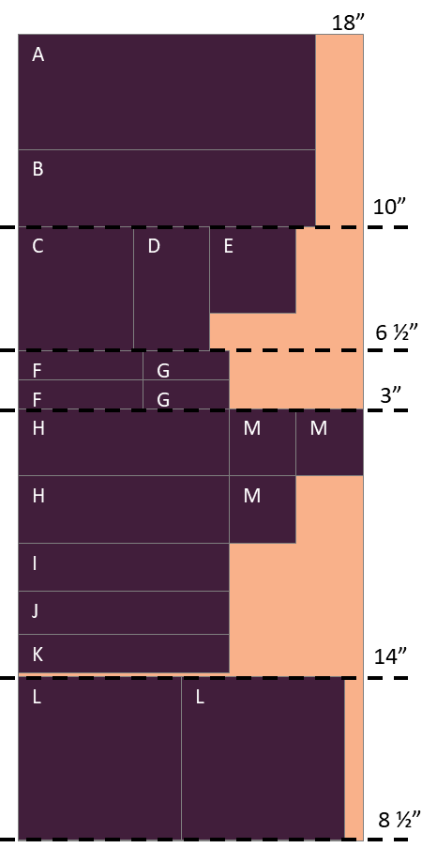
From each of the 4 half yards cut and label the following:
- From a 10” x 18” section, cut:
  - (1) 6” x 15½” Piece A
  - (1) 4” x 15½” Piece B

- From a 6½” x 18“ section, cut:
  - (1) 6½” x 6” Piece C
  - (1) 6½” x 4” Piece D
  - (1) 4½” x 4½” Piece E

- From a 3” x 18” section, cut:
  - (2) 1½” x 6½” Piece F
  - (2) 1½” x 4½” Piece G

- From a 14” x 18” section, cut:
  - (2) 3½” x 11” Piece H
  - (1) 2½” x 11” Piece I
  - (1) 2¼” x 11” Piece J
  - (1) 2” x 11” Piece K
  - (3) 3½” x 3½” Piece M

- From the remaining 8½” x 18“ section, cut:
  - (2) 8½” x 8½” Piece L

- We will sub-cut Pieces H and L in the workshop.
Post Workshop Assembly Instructions:
In case we aren’t able to assemble your wall hanging or table runner in class, here are some suggested layouts that will prevent the need for partial seams. Of course, any layout that is pleasing to your eye is best, and I would encourage you to take some time and experiment with alternative block layouts and orientations.

36” x 36” wall hanging:
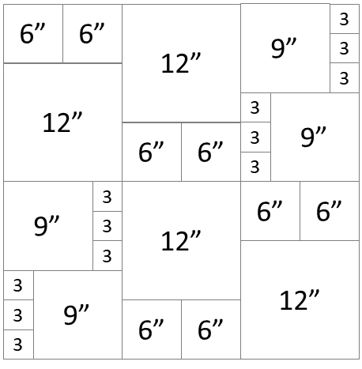

18” x 72” Table runner:
